(Q-1)• List out the platforms available for Social Media Marketing.
ANS:-
Mainstream:
- Facebook
- Instagram
- Twitter
- LinkedIn
- YouTube
- Reddit
Visual-Centric:
- Flickr
- Vimeo
- Tumblr
- DeviantArt
- Behance
E-commerce:
- Shopify
- Amazon
- Etsy
- eBay
- WooCommerce
Influencer:
- AspireIQ
- Upfluence
- HYPR
Management Tools:
- Hootsuite
- Sprout Social
- Buffer
Analytics:
- Google Analytics
- Facebook Insights
- Twitter Analytics

(Q-2) How many types of content we can use for Social Media Marketing? Explain any three.
ANS:-
Types of Social Media Content:
- Visual Content (images, videos, infographics)
- Text-Based Content (posts, articles, blogs)
- Interactive Content (polls, quizzes, contests, surveys)
Other types:
- Audio Content
- Video Content
- User-Generated Content
- Influencer Content
- Educational Content
- Emotional Content
- Promotional Content
(Q-3) Why should we use Social Media Marketing to promote our business?
ANS:-
Benefits:
- Increased Brand Awareness
- Targeted Audience Reach
- Improved Website Traffic
- Enhanced Customer Engagement
- Cost-Effective Advertising
- Competitive Advantage
- Data-Driven Insights
- Improved Customer Service
- Increased Sales and Conversions
- Global Reach
Why Social Media Marketing?
- 4.2 billion active users worldwide
- 70% of online adults use social media
- Average user spends 2.5 hours/day on social media
- 71% of consumers recommend brands after positive social media experiences

Invest in Social Media Marketing to:
Grow your business
Boost online presence
Drive sales and revenue
Stay ahead of competitors
It's essential for businesses to leverage social media marketing to reach, engage, and convert their target audience.

(Q-4)What is the relationship between SEO and Social Media Marketing
ANS:-
SEO Benefits for Social Media:
- Improved visibility
- Increased website traffic
- Enhanced credibility
Social Media Benefits for SEO:
- Social signals (likes, shares)
- Content promotion
- Link building
- Local SEO enhancement
Shared Goals:
- Online visibility
- Website traffic
- Leads and sales
- Brand awareness
Integration Strategies:
- Share blog posts
- Optimize profiles
- Use keywords
- Analyze social media insights
- Leverage influencer

(Q-5) Prepare a word file in which you should add:
o Type of content to create on YouTube for http://www.designer2developer.com
o Suitable topic list for http://www.designer2developer.com according to your research on Google trends
o List out the points to include in the video
o Suitable title and description for the video o Keywords to target and its placement
ANS-:
I. Type of Content to Create:
- Educational/Tutorial videos
- Case studies/Success stories
- Product demos
- Webinars
- Industry news/Updates
II. Suitable Topic List (based on Google Trends research):
- IoT Development
- Mobile App Development
- Web Development
- AI/Machine Learning
- UX/UI Design
- E-commerce Solutions
- Education Technology
- Blockchain Development
- Progressive Web Apps
IV. Points to Include in the Video:
- Introduction to IoT
- Benefits of Smart Home Systems
- Design considerations
- Development process
- Case study/example
- Challenges and solutions
- Future trends in IoT
- Conclusion/Call-to-action
V. Video Title and Description:
Title: "Building a Smart Home System with IoT: A Step-by-Step Guide"
Description: "Learn how to build a smart home system using IoT technology. Our experts at Designer2Developer share their expertise in designing and developing innovative IoT solutions. Watch till the end for a real-life case study!"

VI. Keywords to Target:
1. IoT development
2. Smart home system
3. Mobile app development
4. UX/UI design
5. Healthcare technology
6. E-commerce solutions
7. Artificial intelligence
8. Machine learning

VII. Keyword Placement:
1. Video title
2. Video description
3. Tags
4. Thumbnail image (text overlay)
5. Closed captions/subtitles

(Q-6) What are tools we can use for Marketing on a platform like Facebook and Instagram?
ANS:-
Facebook Tools:
- Facebook Ads Manager
- Facebook Insights
- Facebook Pixel
- Facebook Groups
- Facebook Messenger

Instagram Tools:
- Instagram Insights
- Instagram Ads
- Instagram Stories
- Instagram Reels
- Instagram Shopping

Third-Party Tools:
- Hootsuite
- Buffer
- Sprout Social
- Canva
- Adobe Creative Cloud

Categories:
- Advertising (Facebook Ads, Instagram Ads)
- Analytics (Facebook Insights, Instagram Insights)
- Content Creation (Canva, Adobe)
- Social Media Management (Hootsuite, Buffer)
- Influencer Marketing (AspireIQ, Upfluence)

(Q-7) What type of traffic you will get on platform like Linked-In?
Demographics:
ANS:-

- Professionals
- Business owners
- Decision-makers
- Industry experts
- Job seekers
Intent:
- Networking
- Job searching
- Industry research
- Professional development
- B2B marketing
Benefits:
- B2B leads
- Networking
- Brand visibility
- Website traffic

(Q-8) Create social media presence (page or account) which helps your website and blog.
ANS:-
Facebook link:
https://www.facebook.com/magicphotographystudio
linkdin link : https://www.linkedin.com/company/104954273/admin/dashboard/

(Q-9) Prepare an excel sheet for posts of www.esellerhub.com to publish on Facebook, Instagram and Linked In.
ANS :-

(Q-10) What is the use of E-mail marketing?
ANS-
Main Objectives:
- Lead generation
- Conversion and sales
- Brand awareness
- Customer retention
- Relationship building
Benefits:
- Targeted audience
- Cost-effective
- Measurable results
- Increased conversions
- Improved engagement
Types:
- Newsletters
- Promotional emails
- Transactional emails
- Automated sequences

(Q-11)What goals you can achieve with the help of email marketing?
ANS-

Primary:
- Generate Leads
- Drive Sales
- Build Brand Awareness
- Improve Customer Retention
- Enhance Engagement
Secondary:
- Nurture Prospects
- Re-engage Customers
- Reduce Cart Abandonment
- Improve Loyalty
- Gather Feedback
Long-term:
- Customer Loyalty Programs
- Thought Leadership
- Referral Programs
- Increase Lifetime Value
- Improve ROI

(Q-12) Set-up an automation email for www.esellerhub.com abandon cart.
o Suggest a Subject for the email.
o Prepare an email
ANS-
Ans :-
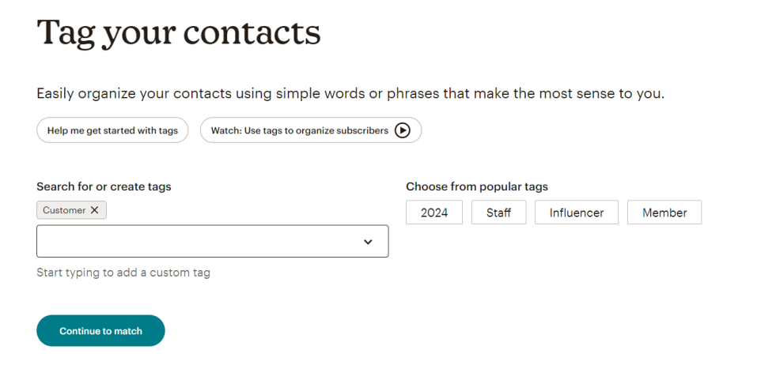

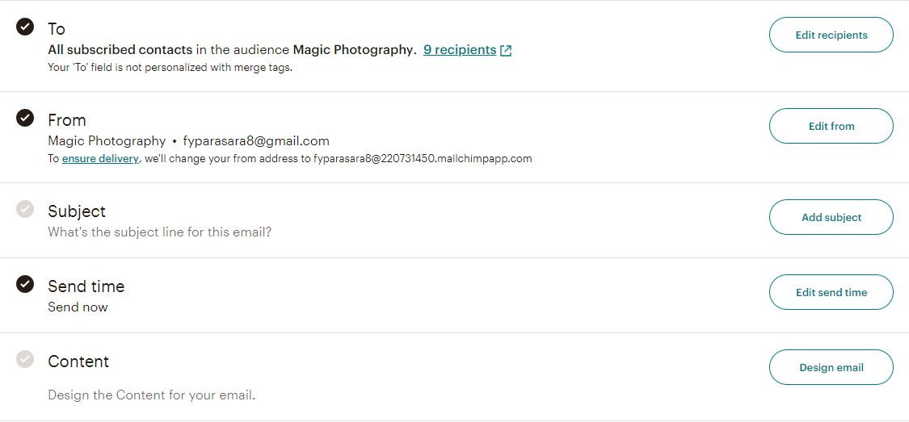
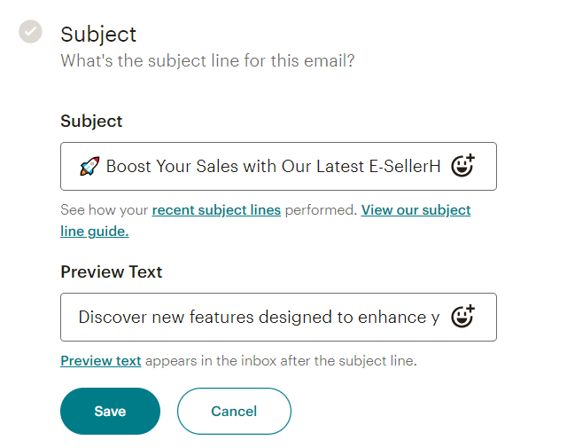
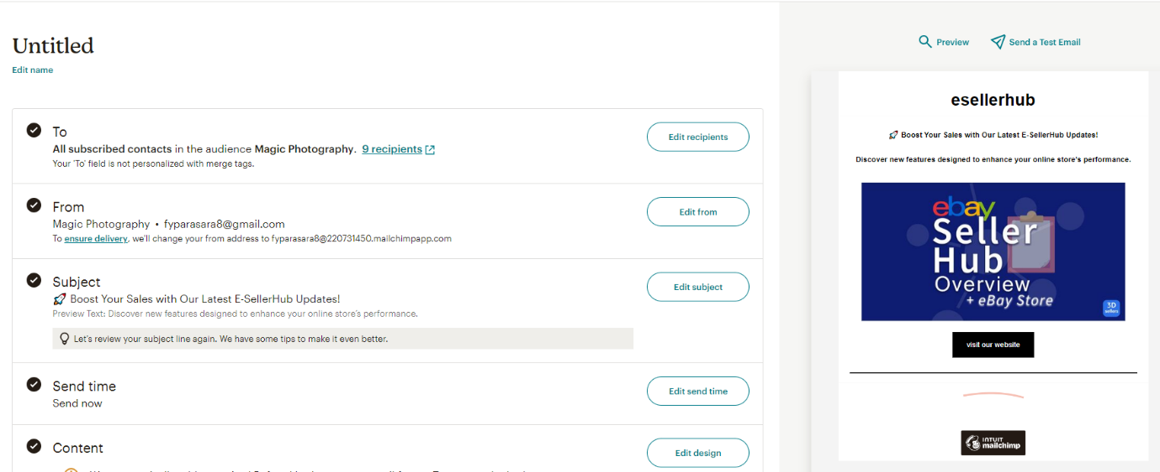

(Q-13)Create Sign-up / Subscriber pop-up form for your blog and website using email marketing tools to collect audience data.
ANS-
https://magicphotography1.blogspot.com/
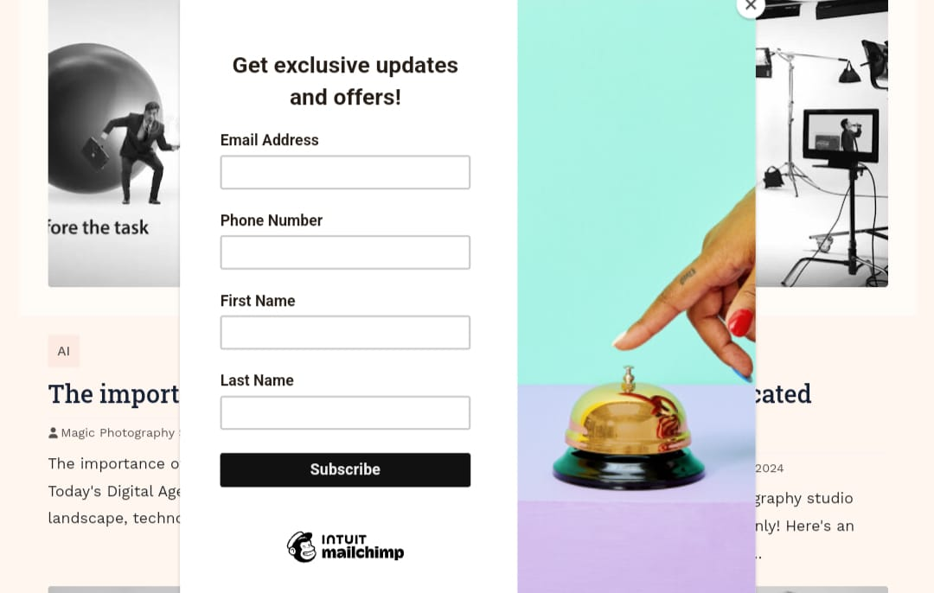

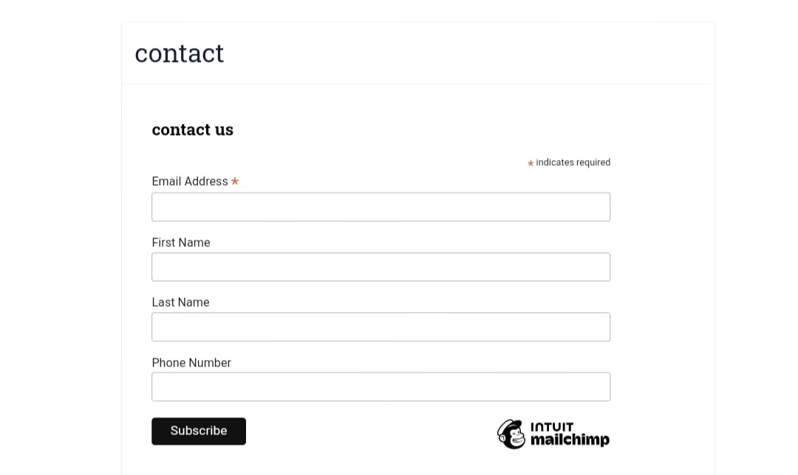

(Q-14)What is affiliate Marketing?
ANS-

Affiliate Marketing:

Performance-based marketing:

Merchant + Affiliate + Customer

Benefits:
- Low costs
- Passive income
- Flexibility
- Scalability

Types:
- Pay-per-Sale
- Pay-per-Lead
- Pay-per-Click

Popular Programs:
- Amazon
- ShareASale
- ClickBank
- Commission Junction
- Rakuten

(Q-15) List some famous websites available for affiliate marketing.
ANS-
- Amazon Associates
- ShareASale
- ClickBank
- eBay Partner
- Rakuten
Digital:
- JVZoo
- WarriorPlus
- PayDotCom
Travel:
- Expedia
- TripAdvisor
- Airbnb
Other:
- Shopify
- Microsoft
- Apple
- Google
- IBM

(Q-16) Which are the platforms you can use for affiliate marketing
Networks:
ANS-
- Amazon Associates
- ShareASale
- ClickBank
- Commission Junction
- Rakuten
Social Media:
- Instagram
- YouTube

- Facebook
- Twitter
Content Platforms:
- WordPress
- Blogger
- Medium
Email Marketing:
- Mailchimp
- ConvertKit
- AWeber
Influencer Marketing
- AspireIQ
- Upfluence
- HYPR
E-commerce:
- Shopify
- WooCommerce
- BigCommerce
Tracking Tools:
- Google Analytics
- Affiliate Tracker
- Voluum

